REPORT ON EXPERT TALK ON MATHEMATICAL AND COMPUTATIONAL MODELING IN GROUND WATER HYDROLOGY
Name of expert : Dr. Suresh A.Kartha, Associate Professor,IIT Guwahati
Date: 29/10/2019
The session was handled by Dr. Suresh A. Kartha, Associate Professor at the Department of Civil Engineering, IIT Guwahati. He had worked as Visiting Associate Professor in Water Engineering Management, School of Engineering and Technology, Asian Institute of Technology, Bangkok, Thailand. Some of his areas of interest are Groundwater hydrology and hydraulics, Environmental Landfill Leaching, Hydrology, Mathematical and Numerical Modeling.
The session started at 9.30 am, and extended over 3 hrs. He started with brief introduction about Groundwater and sources causing its contamination. He explained about the concept of model, which was defined as anything that describes the real phenomenon. The various phenomenons are mathematically modeled by using algebraic equation, Partial differential equation, ordinary differential equation etc. He also mentioned the method used for solve those equation which are analytical, graphical, and numerical.
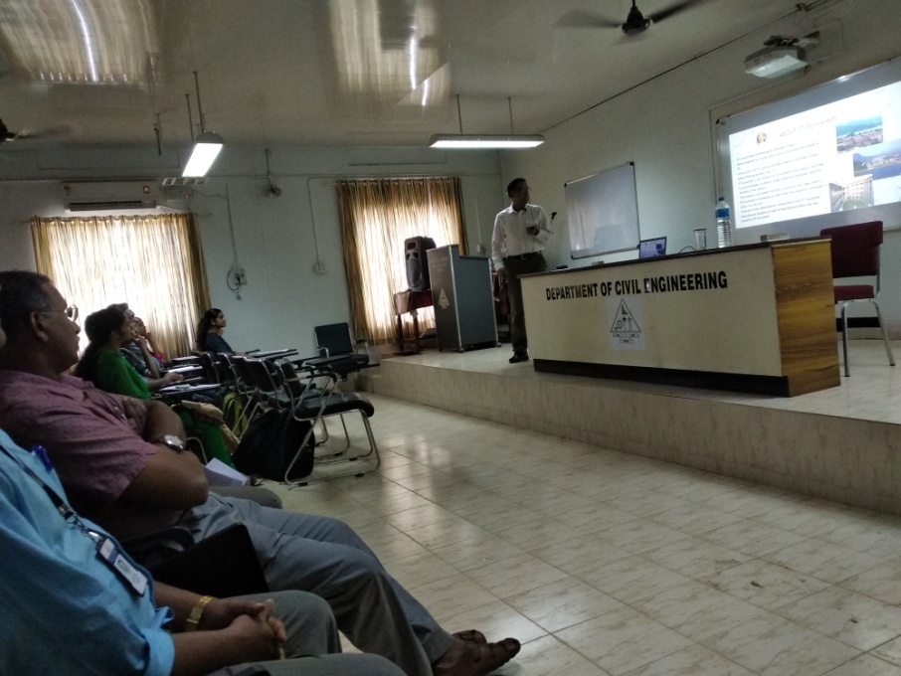
The Lagrangian approach for analyzing solid particle was interconnected with Euilerian approach for fluid to develop general conservation theorem called Reynolds transport theorem. Reynolds transport theorem is used for developing the governing equations for groundwater flow and solute transport. For developing the partial differential equation for contaminant transport through groundwater the phenomenon like advection dispersion, sorption, degradation etc are considered. Among these advection dispersion are surface phenomenon and sorption, degradation are volume phenomenon. He explained in a brief the initial condition and boundary condition that are required for solving the partial differential equation. The boundary condition that can be applied are Dirichlet boundary condition, Neuman boundary condition condition and Mixed boundary condition.
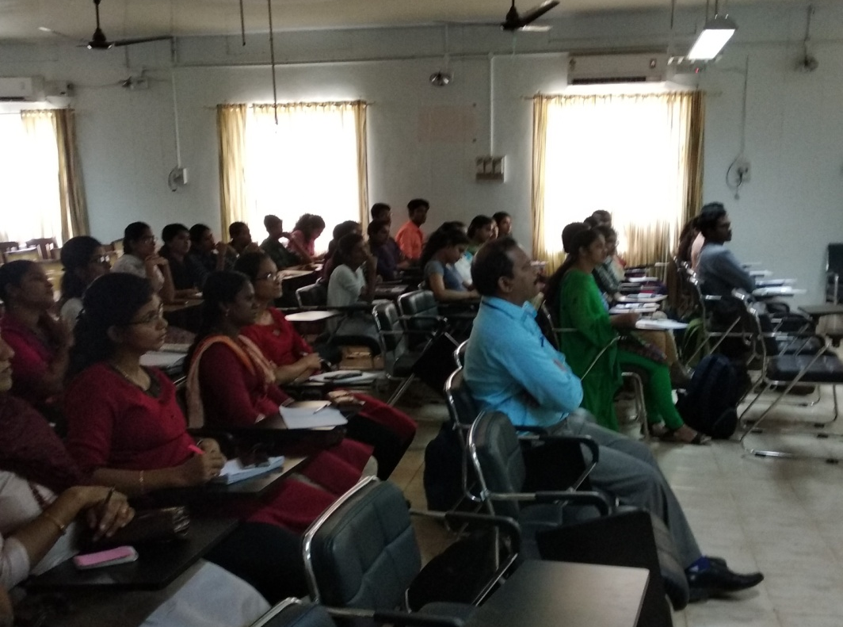
The session was very informative and the lecture gave an overall idea about the mathematical and computational modeling in groundwater hydrology.

