REPORT ON EXPERT TALK (under TEQIP)
CONTAMINANT TRANSPORT MODELLING
Date: 3/10/2019
Expert: Dr. Murthy B.S. , Professor IIT Chennai

The interactive session was conducted by Dr. B. S. Murthy from IIT Chennai .He completed his Bachelors in Civil Engineering from N I T Trichy. He completed his masters from IISC Bangalore. He was awarded the Ph.D degree by the Washington State University. He is currently working as a professor of Civil Engineering. Some of his areas of interest include Open channel flows & Free Surface Flows, Sediment Transport Modeling, Contaminant Transport Modeling. He has several publications in international journals and has undertaken several research and consultancy projects.

The 2 hour session started with an introduction to contaminant and transport. He explained those terms and went on to describe about the different ways through which contaminants get transported. It can be transported through injection,design,accident or by neglect. He went on to explain the various sources contaminating groundwater.
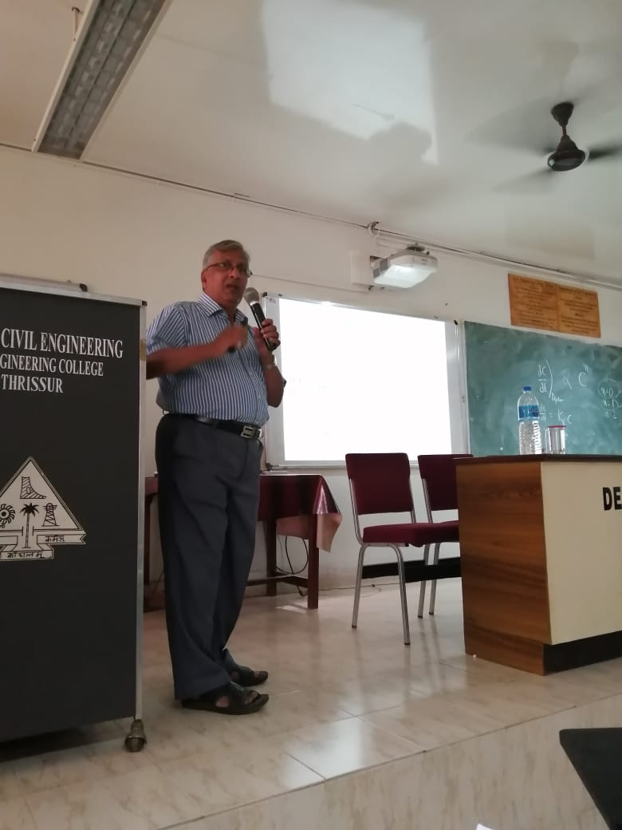
Further before moving on to the modeling, he explained the various goals of water quality protection and how this goal can be achieved. Further he moved on explain the process of modeling. Modeling are done through mathematical equations. Equations are of four trypes algebraic, laws of mechanics, PDEs and empirical. The applications of contaminant transport models are Waste load allocation problems, source identification problems, EIA of large water resource projects, design of cleanup methods for field conditions. Further he explained a case study of a chromium disposal site. The site of the case study was TCCL. Chromium six is one of the main pollutants released into the environment. The potential of Chromium six to cause effects on the surrounding environment is very high. So usually the Cr 6 is converted o Cr 3 which is much stable. The trivalent version is much stable and less soluble in water. On the basis of study conducted by IIT Madras they found out that the permissible levels had been breached in most of the locations. The levels came within the permissible limits only when the sites neared to the Palar river.
Before moving onto the formulation, he explained the dispersion mechanism. Hydrodynamic dispersion can take place through three forms. It can be through molecular diffusions, turbulent diffusion, dispersion due to averaging procedure. Then he moved onto the formulation for the transport of contaminants. He explained first about the governing equations of the model. The formulation included considering various aspects like transport of BOD and DO in streams,solute transport in groundwater, and mechanical dispersion.
Overall the seminar was very informative and introduced us on finding out the transport of contaminants. Further some relevant doubts came up after the discussion such as whether the equations were valid for undissolved as well as large particles.
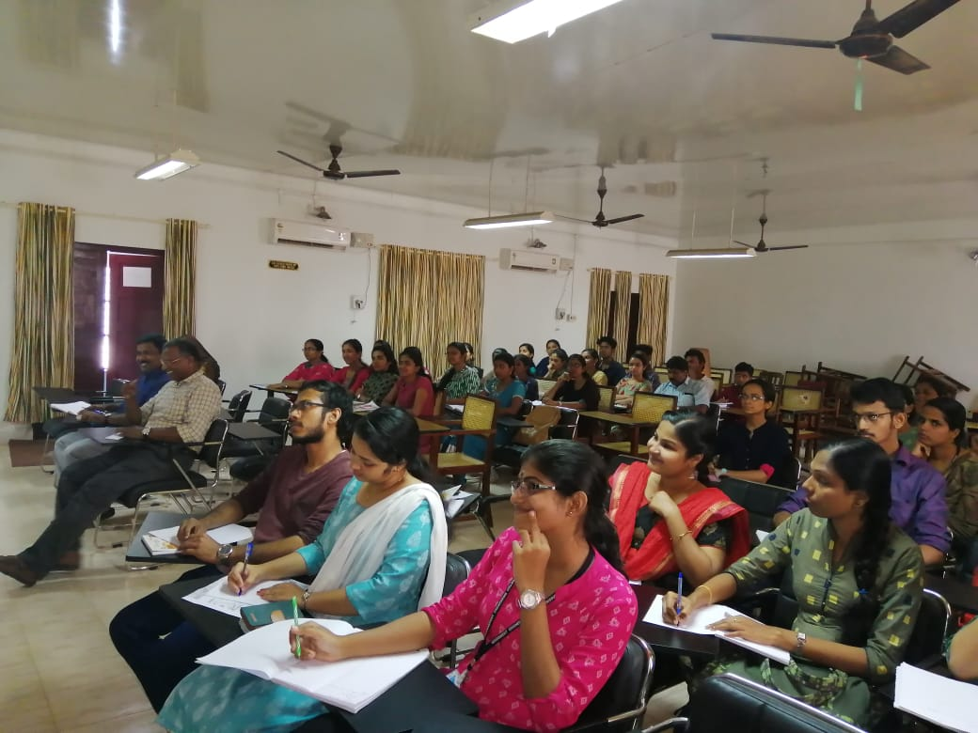
EXPENSEFOREXPERT TALKBY PROF> MURTHY
Sl.No. | Item | Amount (Rs. )
1.  1 | Remuneration  Honorarium | 5000
2. | TA | 11395
3. | Accommodation | Nil
4. | Refreshments to students/expert | 1163
Total |  | 17558

