REPORT ON EXPERT TALK: AIR QUALITY MODELLING
Scheme: Expert talk under TEQIP
The expert talk on air quality modelling by Prof. Mukesh Khare of IIT Delhi started at 9.00am. The first session of the talk was about the topic ‘Fundamentals of air pollution modelling’. According to OECD, air pollution is the transfer of harmful and/or of natural/synthetic materials into the atmosphere as direct/indirect consequences of human activity. Basics of air pollution and air pollution modelling were also discussed. The models are used to assess the current and potential future air quality due source emissions for framing policy decisions. The agents involved in creating air pollution was thoroughly discussed. The effect of air pollution on receptors are also discussed. Empirical, conceptual and numerical models for air pollution and suitability of each type of model were also described in depth. Case histories in India including that of Taj Mahal and abroad on air pollution rates and intensities were shown The session is ended up with a suggestion that it is better not to pollute air than finding solutions to get rid of the air pollution.
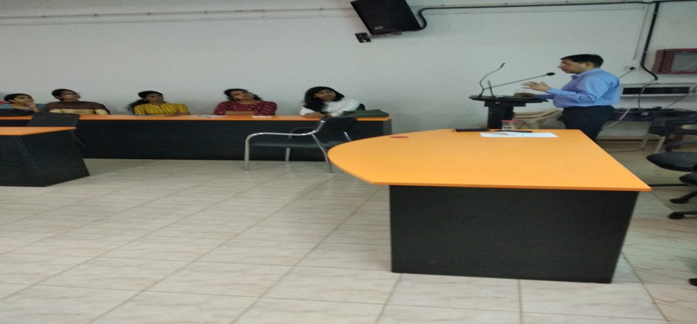
The second session covered was ‘Back Trajectory based modelling for PM2.5 using HYSPLIT’. The talk was all about the transportation of pollutants from different areas. Using HYSPLIT modelling, the position of a unit air mass is predicted 72 hours ago. This is done in every hour at a location and by using this trajectory with similar trends is clustered to simplify the computation.
