REPORT ON EXPERT TALK BY Dr. LIGY PHILIP
Name of Expert : dr. ligy Philip,Professor, IIT Chennai
Scheme:TEQIP
Date: 13/12/2019
The session was handled by Dr. Ligy Philip, professor from IIT Madras. The topic of the session was ‘Sustainable wastewater treatment systems’. The session began with the introduction of importance of water and scarcity of potable water. It addressed the uneven distribution of water which led to extreme scarce conditions in areas like Chennai. The contamination of surface and subsurface was also pointed as of serious concern in this scenario. It was demonstrated from her experimental studies that most of the tube wells were more contaminated with fecal coliform than the open wells. This shows how subsurface waters are more prone to contamination than surface water. The reason for this subsurface water contamination was justified with the geomorphology of the area. The area under study had underlying fractured rocks, so any leaching from sources like septic tanks (which can cause fecal contamination) can easily reach the confined aquifer source without much filtration. Thus tube wells can be more contaminated with fecal coliform. What Ma’am try to convey is that, it was more important to study the geomorphology and hydrology of the area of study before suggesting any waste water treatment method. Areas of underlying fractured rocks should not be suggested for normal two pit systems.
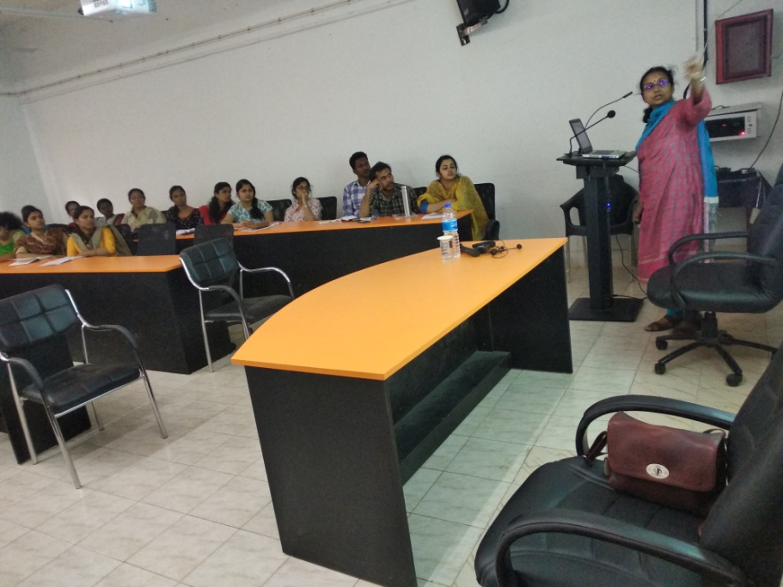
Similarly when the water table is high, those areas are not suitable for normal septic tanks, special design should be given. It was also established by her studies that areas around Namakkal in Tamil Nadu, the water resources of open defecation areas where less contaminated than those with septic tank systems. So blindly going for any wastewater treatment system without study can rather adverse impacts.
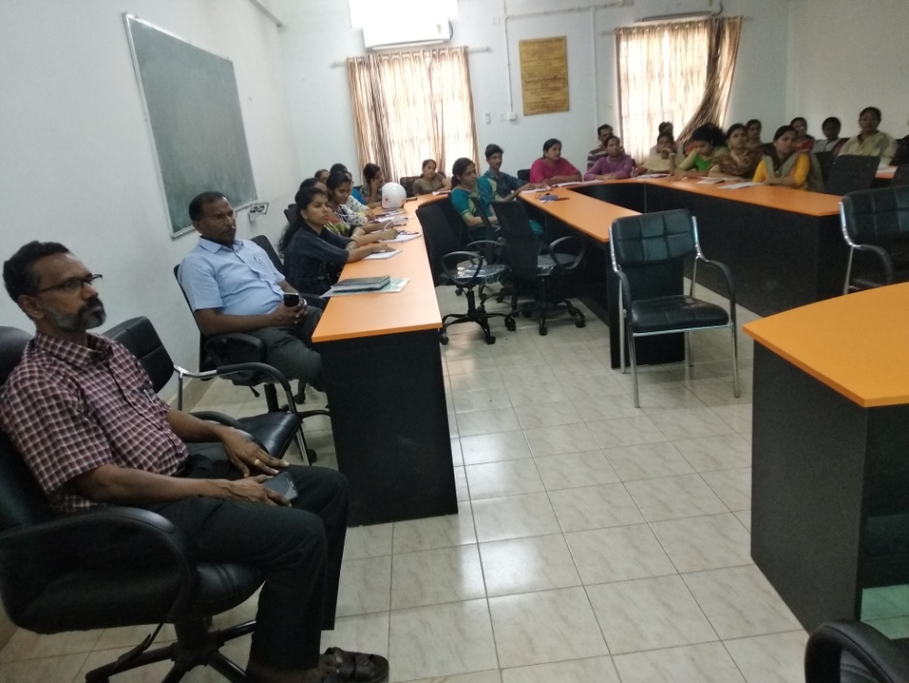
She also addressed some of the new projects guided by herself on the reuse of wastewater, which was really relevant in areas like Chennai which faces extreme water scarce conditions. Some of the projects included recovery and reuse of wastewater from campus of IIT Madras. The whole wastewater generated was collected and given for treatments like screens, grit chamber, equalization tank, sequencing batch reactor and ultrafiltration units followed by ozonation. The water after undergoing these treatments was directly used for activities like toilet flushing, gardening etc..The remaining water was stored in a pond inside the campus and supplied as for other uses after proper treatments along with the metro water. This idea was also accepted by Tamil Nadu government for its areas to overcome water scarce conditions. She also made us aware about the main challenge of getting public acceptance which is difficult due to psychological reasons. Thus innovations like reuse of washed water from a washing machine for other cycles, treating wastewater from washrooms and their reuse for toilet flushing etc. were discussed. These ideas were truly inspiring and made us think differently unlike the conventional methods to find effective solutions for water crisis problems. The session also helped us to understand the importance of knowing geomorphology and hydrology of an area before suggesting the treatment method.

