REPORT ON EXPERT TALK: RESEARCH METHODOLOGY

Expert: Dr. Jothiprakash V., Professor, IIT Bombay
Date: 27/9/2019

The expert lecture on Research methodology was taken by Dr.Jothi Prakash, Professor IIT Bombay. The session started at 1.30pm. It was a detailed and in depth discussion regarding the various aspects of research in all fields including engineering .The lecturer also pointed on the importance of student teacher relationship on various stages of our learning and research path.
The research study of any subject can be defined as a methodological way of arriving the solution for given problem. The organizational skill and well planned methodologies are required for continuing a progressive development on our research work. This type of work can leads us to achieve a thesis in a very simple language and can write all discussions of results you got in your research journey to make your journal relevant to the respective field.
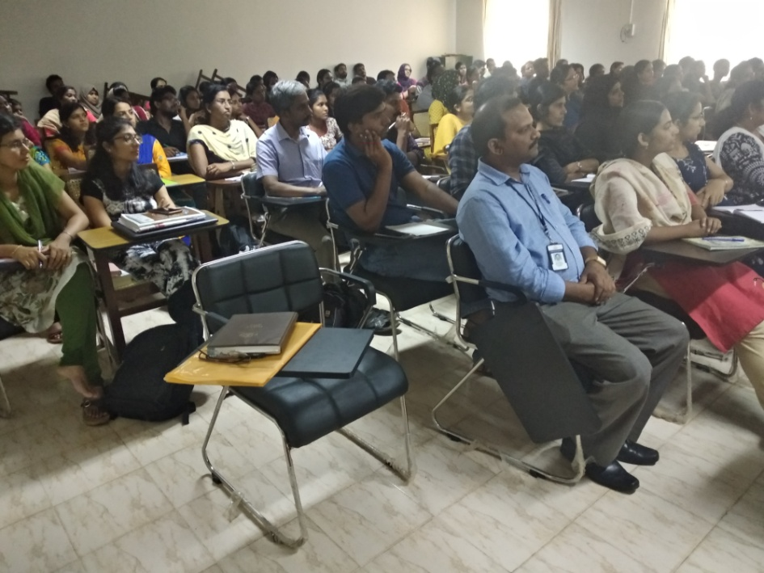
The important steps to make your thesis to a reputed journal is only by writing a very conclusive abstract in such a manner it can explains all the research impact of your entire study. When you write your thesis always keep up the novelty and scientific aspects in a balanced way. The session was all about shaping a student in such a way he/she can pick up the thread in their mind to make a long term vision to achieve their research goal. After the detailed discussion on research methodology and writing a thesis ,the session was closed around 4.30pm.

