REPORT OF LECTURE UNDER VISITING FACULTY SCHEME

AT GEC THRISSUR

- Name and Address of Visiting Faculty: Dr. George K Varghese
Assistant Professor,
Dept of Civil Engineering,
NIT Calicut

- Date and Time of Lecture : 13.06.2019, 2 PM
- Topic of Lecture : “AIR POLLUTION FORENSICS”

ABSTRACT
An expert talk was organized on 13.06.2019 under VFS about the topic AIR POLLUTION FORENSICS. The expert faculty was Dr.George K Varghese, Assistant Professor, NIT Calicut. Session started at 2 pm.
Dr. George K Varghese started his talk by explaining about the environmental laws that exist in India as well as internationally. He then started explaining about the various air pollutants and the method by which these can be analysed. Forensics is the method by which various air pollution cases shall be investigated using various methods of analysis of pollutants. The various analysis methods were also being discussed.
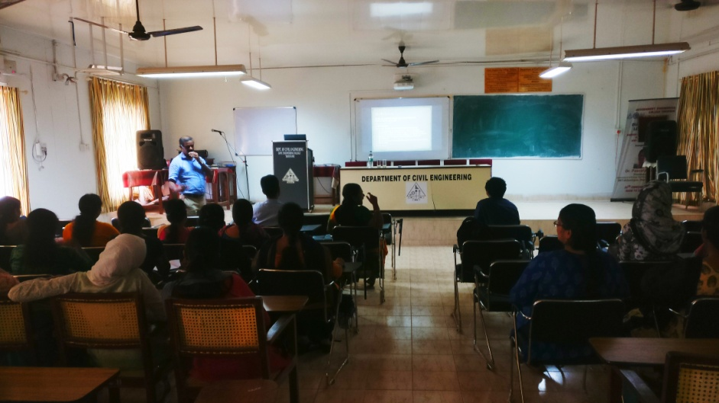

About 36 students of fourth and second semester M Tech Environmental Engineering and faculty of Civil Engineering Dept. attended the talk. Students were so curious about this topic. An interactive session followed by the expert talk was also there, in which students asked many questions on these interesting and innovative topics. Dr. George K Varghese pointed out the scope and opportunities for research, for students in these areas.
Student representative has given the vote of thanks. The session came to an end by 3.30 p.m

