REPORT OF LECTURE UNDER VISITING FACULTY SCHEME SPONSORED BY TEQIP

- Name and Address of Visiting Faculty: Dr. Ajay Kumar R.
Staff Development Engineer.
SEAGATE Technology, USA,

- Date and Time of Lecture : 05/08/2019, 10 AM
- Topic of Lecture : “The path from certainty to uncertainty:
inverse problems, uncertainty quantification and machine learning”

ABSTRACT
The topic was introduced by giving a real life example of how everybody moves from the path of certainty to uncertainty while graduating from a college to searching for a job. The topics that were highlighted, were fluid dynamics in which the phenomena of turbulence which has been investigated mainly by Prandtl and Von Karman is still not perceptible, and machine learning which requires continuous evaluation of the theory for application in field and to build and test a prototype. The real time examples of machine learning were given as the working of Uber and Google Earth.
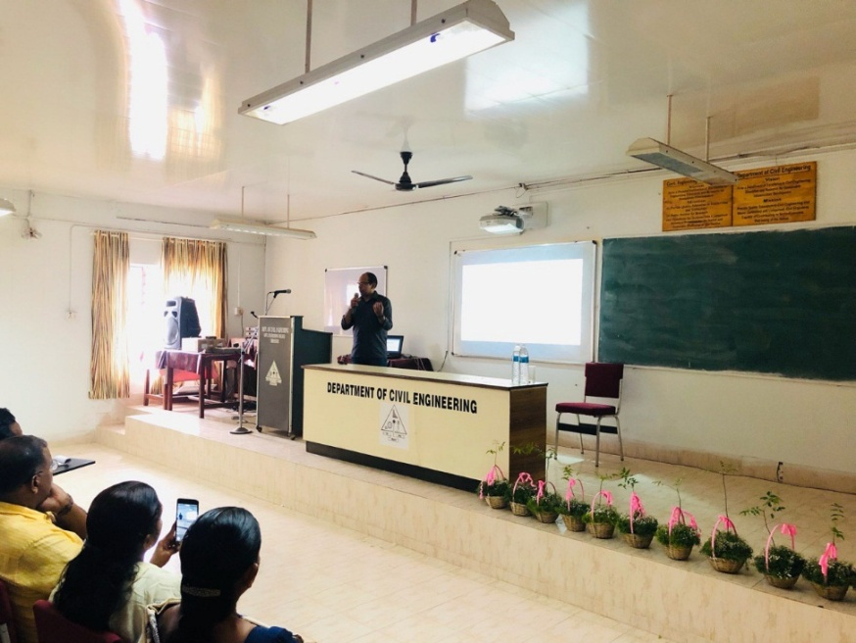
Modeling the continuum using superposition principle was also explained, how these superposition principles are formed from a reverse operation i.e. from whole to parts. Models are built using many basic assumptions as in Casiglano’s theorem by incorporating strong as well as weak forms of differential equations. Whereas integration from parts to whole can be applied for complicated problems as in analyzing the forces and moments for a very complicated beam structure. He also highlighted the application of some differential equations in this application. The example for an inverse problem was explained as calculating the stiffness of a beam from known points and vibrations. The problem with inverse approach is that it is very difficult to prove or validate the solutions obtained. Example for an inverse problem is the Hamilton equation.
Furthermore, the inverse operations require repetition of experiments for verification purpose which can be a costly procedure and the quantification is done by simulations. In uncertainty quantification in machine learning the example of Google or internet was given where all our actions are data points to create a huge database.
The talk concluded byhighlighting the future scope of Artificial Intelligence incorporated with machine learning and the basic principle was also explained by the working of a neural network. This session was over at 12.30pm.
Head of the department Dr. C.V. Lal felicitated the occasion and handed over the amementoto him as a token of appreciation and love.


