REPORT OF LECTURE UNDER VISITING FACULTY SCHEME

AT GEC THRISSUR

- Name and Address of Visiting Faculty: Dr. Arun Kumar
Associate Professor,
Dept of Civil Engineering,
IIT Delhi

- Date and Time of Lecture : 13.06.2019, 12 PM
- Topic of Lecture : “UNDERSTANDING EMERGING
CONTAMINANTS EXPOSURES DURING WATER REUSE”

ABSTRACT
An expert talk was organized on 13.06.2019 under VFS about the topic UNDERSTANDING EMERGING CONTAMINANTS EXPOSURE DURING WATER REUSE. The expert faculty was Dr.Arun Kumar, Associate Professor, IIT Delhi. Session started at 12 pm. with a welcome speech by HOD, Dr. C V Lal.
Dr. Arun Kumar started his talk about fundamentals of nano particles, which may be present in the effluent water. The sources of these nano particles were also discussed. The treated water is mainly used for irrigation purposes, so the nano particles present in this water may cause problems to the plants. So the problems caused to the plants due to the presence of nano particles in the irrigation water were explained. The techniques to analyse the presence of the nano particles in plants were also discussed.

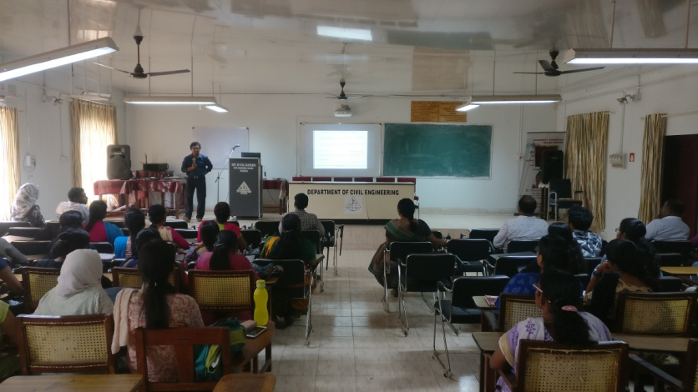

About 36 students of fourth and second semester M Tech Environmental Engineering and faculty of Civil Engineering Dept. attended the talk. Students were so curious about this topic, as some are doing projects on nano particles. An interactive session followed by the expert talk was also there, in which students asked many questions on these interesting and innovative topics. Dr. Arun Kumar pointed out the scope and opportunities for research, for students in these areas.
Student representative has given the vote of thanks. The session came to an end by 1.30 p.m

