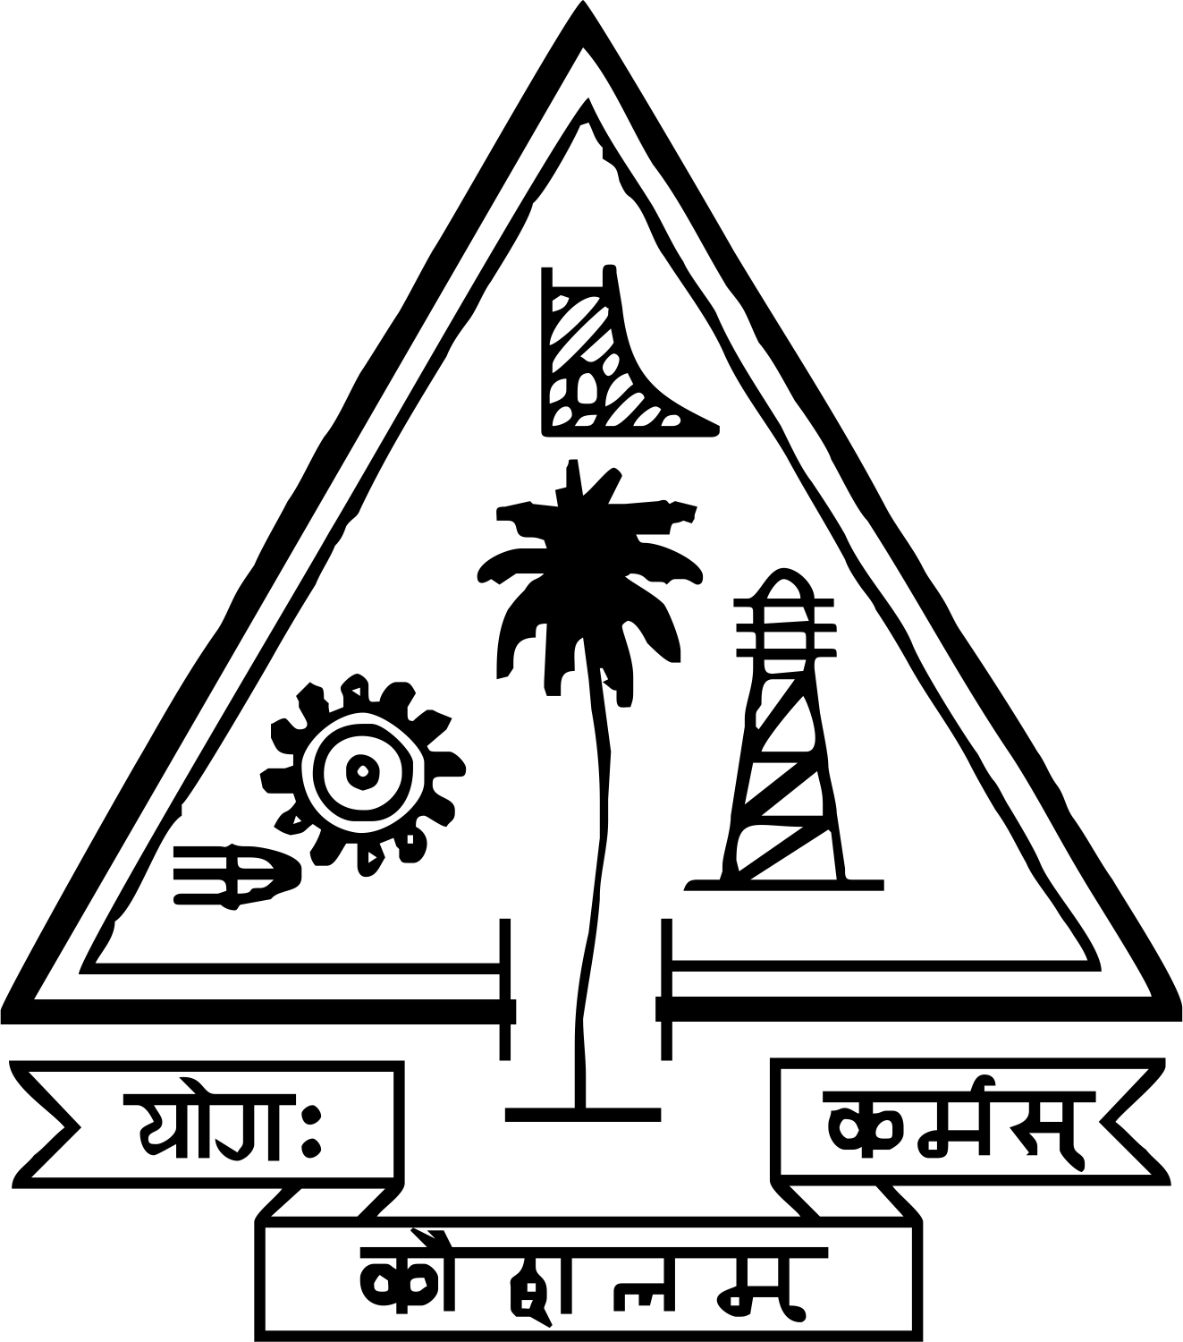
ALUMNI SURVEY
Department of Electrical Engineering
Government Engineering College, Trichur
Thrissur, Kerala
www.gectcr.ac.in

Dear Alumna/Alumnus:
This is an annual survey conducted on the alumni of the institution to assess the impact of the Graduation course in Electrical& Electronics Engineering, Department of Electrical Engineering, Government Engineering College, Trichur, on your career and professional accomplishments. This shall be in the interest of improving the academic quality of the above course. Please take a few minutes to answer the following questions.

1. When did you receive your degree? __________________
2. How satisfied are you with the UG education you received from the Dept of Electrical Engineering?
Extremely Satisfied
Somewhat Satisfied
Somewhat Dissatisfied
Extremely Dissatisfied

3. Which of the following best describes your current profession?
Student
Engineer
Scientist
Executive
Professor
Business Owner
Consultant
Unemployed
Other ________________________________

4. In what business setting are you employed? (Indicate all that apply)
Industry
Government
Academia
Other
5. What percentage of your job duties involve:
% working with people or entities outside India
% working in multi‐disciplinary teams
% travel within India
% travel outside India

6. Which of the following best describes your activity in technical or professional societies?
Not a member
Member: Please list: ___________________

7. If a member of a professional society, how often do you attend professional conferences?
Never
Once every couple of years
1‐2 times a year
Other _______________________________

8. What is your highest level of formal education?

Awarded Pursuing
M.Tech M.Tech
PhD/DSc PhD/DSc
MBA MBA
Any other (Specify)

9. Have you pursued other educational opportunities for advancement/enhancement of your profession?
Continuing Education
Technical Symposia
Workshops
Short Courses
Management Training
Leadership Development
Other(Specify)

11. Please list the community service activities, if any, that you are part of.
_______________________________________________________________________________________________________________________________________________________________________________________________________
10. Does your work have an impact on the following fields of technology? Please indicate all that apply:
Materials
Infrastructure
Energy
Electronics
Communications
Transportation
Recreation

12. Below are the Programme Educational Objectives (PEOs), Programme Outcomes (POs) and Program Specific Outcomes of the UG course in Electrical & Electronics Engineering. Please indicate how well you agree with each PEO and PO:
Please put √ in the respective column
1 : Slight(Low) 2 : Moderate(Medium) 3 : Substantial(High) NC : No Correlation
Degree of relevance of the following Programme Educational Objectives (PEOs) --B.Tech. | 3 | 2 | 1 | NC
PEO1:
To mould the students with global standards by providing knowledge in Basic sciences and Mathematics, in general and Electrical & Electronics Engineering in particular
PEO2:
To impart necessary skill and practical knowledge to design, analyze and synthesis Electrical & Electronic systems with effective use of modern problem solving tools and techniques.
PEO3:
To mould the students with effective oral and written communication skills, professional ethics and team work skills for a successful professional career
PEO4:
To instill in students self confidence and leadership qualities to become innovative engineers and entrepreneurs, with an enthusiasm for lifelong learning.
Please suggest whether you require any modifications in the PEO

Programme outcome (Common for all Engg. Branches)
Below are the expected outcomes of the program. Please record your level of attainment for each outcome.
Please put √ in the respective column
1 : Slight(Low) 2 : Moderate(Medium) 3 : Substantial(High) NC:No Correlation

Degree of relevance of the following Programme  Outcomes (POs)—B.Tech. | 3 | 2 | 1 | NC
PO 1: Engineering knowledge: Apply the knowledge of mathematics, science, engineering fundamentals, and an engineering specialization to the solution of complex engineering problems
PO2: Problem analysis: Identify, formulate, review research literature, and analyze complex engineering problems reaching substantiated conclusions using first principles of mathematics, natural sciences, and engineering sciences.
PO3: Design/development of solutions: Design solutions for complex engineering problems and design system components or processes that meet the specified needs with appropriate consideration for the public health and safety, and the cultural, societal, and environmental considerations.
PO 4: Conduct investigations of complex problems: Use research-based knowledge and research methods including design of experiments, analysis and interpretation of data, and synthesis of the information to provide valid conclusions.
PO 5:Modern tool usage: Create, select, and apply appropriate techniques, resources, and modern engineering and IT tools including prediction and modeling to complex engineering activities with an understanding of the limitations.
PO 6: The engineer and society: Apply reasoning informed by the contextual knowledge to assess societal, health, safety, legal and cultural issues and the consequent responsibilities relevant to the professional engineering practice.
PO 7: Environment and sustainability: Understand the impact of the professional engineering solutions in societal and environmental contexts, and demonstrate the knowledge of, and need for sustainable development.
PO 8:Ethics: Apply ethical principles and commit to professional ethics and responsibilities and norms of the engineering practice.
PO 9:Individual and team work: Function effectively as an individual, and as a member or leader in diverse teams, and in multidisciplinary settings.
PO10:Communication:Communicate effectively on complex engineering activities with the engineering community and with society at large, such as, being able to comprehend and write effective reports and design documentation, make effective presentations, and give and receive clear instructions.
PO 11: Project management and finance: Demonstrate knowledge and understanding of the engineering and management principles and apply these to one’s own work, as a member and leader in a team, to manage projects and in multidisciplinary environments.
PO 12: Life-long learning: Recognize the need for, and have the preparation and ability to engage in independent and life-long learning in the broadest context of technological change.

Program Specific Outcomes (PSO).
Please put √ in the respective column
1 : Slight(Low) 2 : Moderate(Medium) 3 : Substantial(High) NC: No Correlation
At the end of the program the graduates are able to

Program Specific Outcomes | 3 | 2 | 1 | NC
PSO 1: Design and analyse the performance of Electric Power system, Electrical Machines, Control systems, Electronic and Power Electronic Systems.
PSO 2: Attain technical competence in developing, testing and implementing Electrical and/or Electronic systems with the effective use of relevant Processors/Controllers and Application softwares.
PSO 3: Apply theoretical concepts and practical skills in providing Electrical and/or Electronics Engineering solutions with a view of Energy conservation and Sustainability.

13. Upon reflection, what course taken during your under graduate education had the greatest impact on your career to date?

14. Please mention any course you would like to have taken, if available to you, during your under graduate education.

15. Give your suggestions, if any, on the reformation of the Program Educational Objectives already developed.

Signature
Name & Designation
Thank you for your participation!

